**Short answer practice questions**

1. Label the indicated parts on the diagram of the alimentary canal shown. (3 marks)

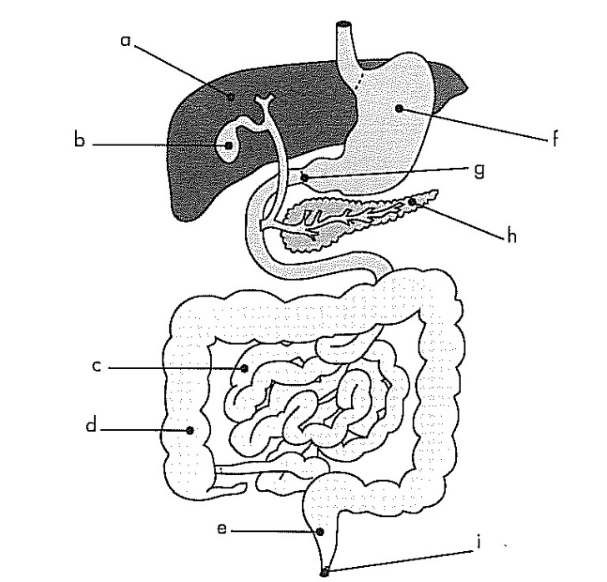

**a:** liver

**b:** Gall bladder

**e:** Rectum

**f:** stomach

**g:** pyloric sphincter

**h:** pancreas

1. State one complication that could occur if “g” did not work properly? (1 mark)

The contents leak out before properly digested, continual acid flow burn intestines etc

1. Explain the role of “b”. In your explanation state why it is vital to the functioning of the digestive system. (3 marks)

Stores bile and releases into intestines

Vital because neutralises chyme so doesn’t burn/enzymes can work

Mechanical digestion of fat so enzymes more effective

1. Fred just ate a dry piece of toast and wondered what happened to it once he put it into his mouth. Write an explanation for Fred on how the piece of toast is digested before it can be absorbed into his blood stream. Include all types of digestion. (5 marks)

Mouth – mechanical digestion eg molars grind or such like

Mouth – saliva amylase starts the break down of starch in bread

Stomach – acid denatures enzyme so no further breakdown/mechanical digestion into chyme

Pancreas adds amylase continues break down starch

Intestine add more amylase finishes off breakdown into glucose/simple sugar/monosaccaride

1. Explain the difference in the position of the bones in the axial skeleton and the bone sin the appendicular skeleton. (1 mark)

Axial – bones attached to spine, appendicular not attached to spine

1. When a long bone is broken this often results in bleeding from the bone. Why does the epiphysis not bleed as much as the diaphysis if it is broken? (2 marks)

Blood vessels dispersed throughout bone as bone cell arrangement random

In diaphysis blood vessels run continually through osteons so break would break all vessels = more

**A**

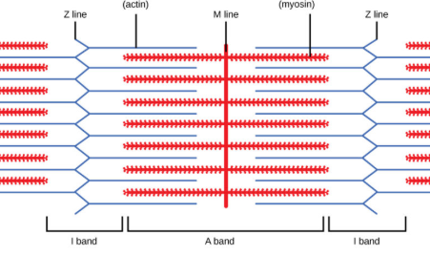

**B**

1. The diagram represents the sliding filament model of muscle contraction. A sarcomere in a skeletal muscle is shown in the relaxed position.
2. Identify the proteins labeled as A and B in the diagram.  (2 marks)

A actin

B myosin

1. In the box below, accurately draw the same sarcomere as it would appear when the muscle is contracted. (2 marks)

Actin and myosin the same length roughly (1)

Shows z-lines closer and sarcomere shorter (1)

1. Explain what will have to happen for the sarcomere to return back to normal. (2 marks)

Cover needs to return to the actin

Actin and myosin can then slide back over each other

1. Why do ligaments take longer to heal than muscles? (2 marks)

Nutrients needed for repair have to diffuse through as no direct blood supply – takes long time

Muscle has very good blood supply so nutrients available quickly and continuosly

1. [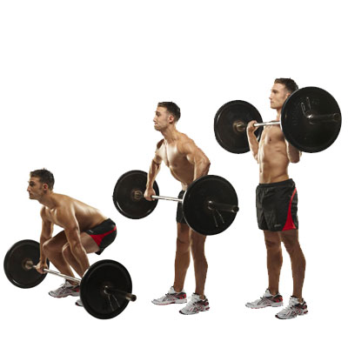](http://www.google.com.au/url?sa=i&rct=j&q=&esrc=s&frm=1&source=images&cd=&cad=rja&uact=8&ved=0ahUKEwiRmNmhvq7NAhXBkpQKHdMlB1EQjRwIBw&url=http://www.top.me/fitness/take-your-fitness-to-the-next-level-with-complex-training-1100.html&bvm=bv.124817099,d.dGo&psig=AFQjCNHMV2agSm44aHcdA0Z3ZtpZXuj0jA&ust=1466233100823096)The “clean and jerk” is an Olympic sport for the powerful. The use of the legs and arms are shown in the diagram opposite.

Using the diagram to help you, discuss how the major muscles, bones and joints in the leg move to achieve the straight leg position. Any four (4 marks)

Quadricep attached to origin in pelvis/hip

Contracts/flexes as it is the agonist

Attached to lower leg/shin, insertion, so pulls the shin closer/forward straightening the leg

Synergists stabilise the knee joint

Hamstring is antagonist, so relaxes/extension allowing calf to move

1. The liver plays a vital role in the recycling of nutrients in the human body. One of its roles is to break down old red blood cells to retrieve the haemoglobin, in doing this it makes waste products that need to be removed, this process is called deamination. Describe the process of deamination. (3 marks)

Proteins broken down to amino acids

Amino acids reacted with oxygen

To form ammonia and carbohydrate

1. How does the body deal with the waste product produced by deamination? (2 marks)

Ammonia is reacted with carbon dioxide and forms urea and water

Urea sent to kidney to be excreted out

1. *Your response to this question can be written in paragraph form, tables or can refer to labelled diagrams in support.*

The nephron is the primary structure concerned with the formation of urine. It is composed of a number of parts, including the:

* 1. Glomerulus
  2. Proximal convoluted tubule
  3. Distal convoluted tubule

Discuss how each of the structures are suits to their functions function. (2 each part) (6 marks)

Glomerulus – big blood vessel coming in small out creating pressure to filter blood

Blood vessels in a ball so concentrated to maximise filtration

Surrounded by Bowmans capsule so all filtrate can be picked up

PCT – very long to maximise reabsorption

Surrounded by blood vessels so nutrients can diffuse easily

Filtrate continually flowing to maintain gradients

One cell thick so nutrients can easily by reabsorbed

DCT – very long to maximise reabsorption

Surrounded by blood vessels so nutrients can diffuse easily

Filtrate continually flowing to maintain gradients

Has receptors for hormones so can regulate the reabsorption of water

Can take nutrients by active transport to regulate the blood